

***IE-322***

**Restaurant Reservation App**

|  |  |  |
| --- | --- | --- |
| ***Team 18*** | | |
| #1 | Ibrahem Shams | 1845896 |
| #2 | Omar manna | 1846397 |
| #3 | Mohammed Balkhair | 1845132 |
| #4 | Adel Alghamdi | 1637396 |
| #5 | Salman Aloufi | 1846504 |

|  |  |
| --- | --- |
| **Instructor** | Dr. Atif Shahzad |
| **Section** | GA |

***King Abdulaziz University***

***Faculty of Engineering***

***Department of Industrial Engineering***

|  |  |
| --- | --- |
| Student/s name | Contribution |
| Ibrahim shams then DR.atif | **Selecting project idea** |
| Ibrahim and salman | **Putting time table** |
| All students | **Learning** |
| Adel alghamdi | **UML diagrams** |
| Omar mannaa with the help of all members | **Coding** |
| Mohamed balkhair | **Testing** |
| Ibrahim and mohamed | **Documenting** |

**Student contirbution**

**Gantt chart**

|  |  |  |  |  |  |
| --- | --- | --- | --- | --- | --- |
| **Week**  **Stage** | **W1** | **W2** | **W3** | **W4** | **W5** |
| **Searching about the idea and discussing it** |  |  |  |  |  |
| **Determine the project idea and main functions** |  |  |  |  |  |
| **Planning and the Gantt chart** |  |  |  |  |  |
| **UML diagrams** |  |  |  |  |  |
| **Coding** |  |  |  |  |  |
| **Testing** |  |  |  |  |  |
| **Documenting** |  |  |  |  |  |

## Description

This app is made to help the restaurant owners to have a simple and useful app for reservation. It can ask the customers what date, time and how many seats the customer needs. The information of the reservation cam be saved in a database or it can be sent via email to the restaurant reservation center and it can be sent to the customer at the same time.

## Uml diagrams

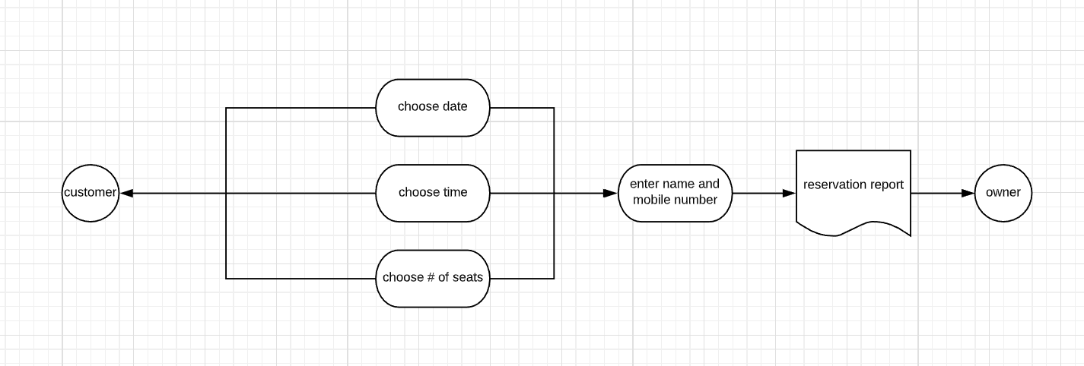

**Output interface**

A – Date selection

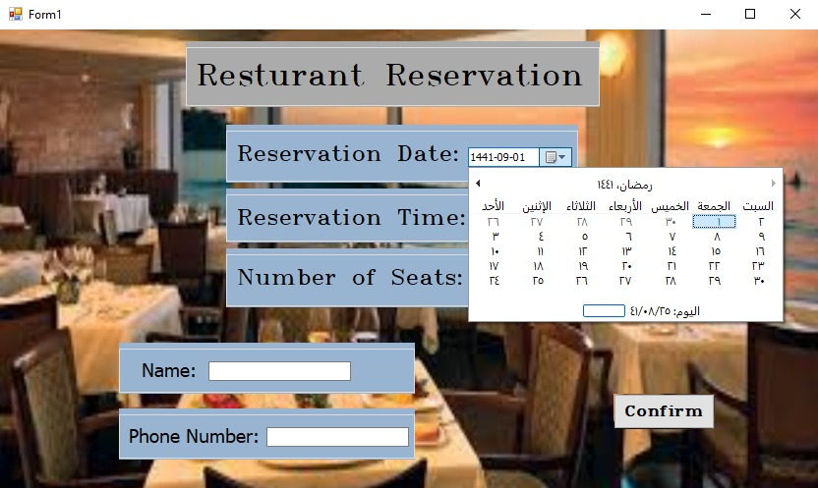

B – Time selection

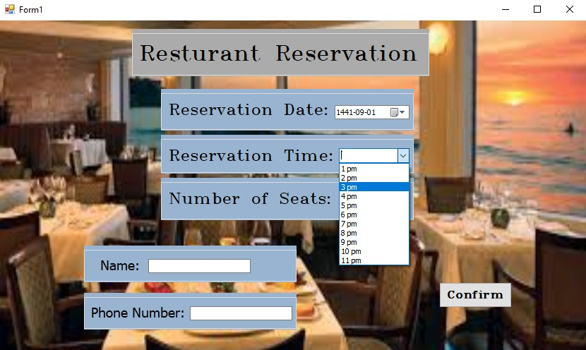

C – Number of seats selection

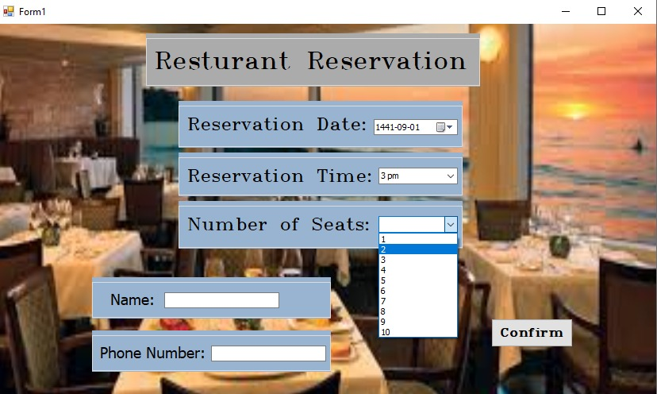

D – Typing the name and phone number

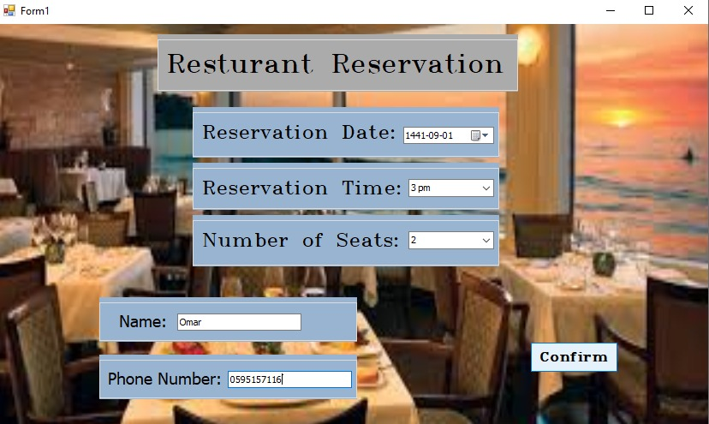

E – Confirming the reservation and receiving a confirmation message

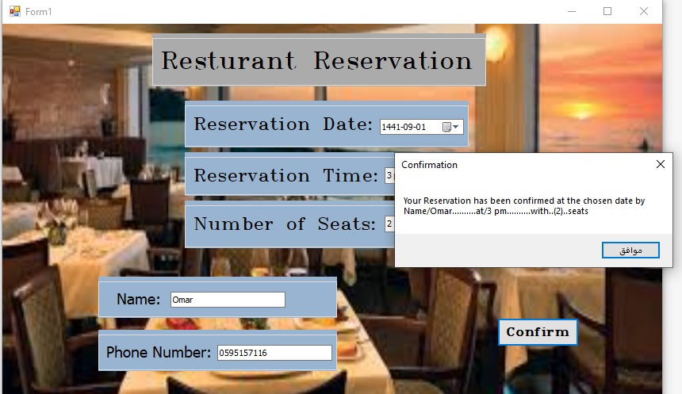

**Codes**

This code is to confirm and shows a confirmation message

